Day_2

Levels of testing

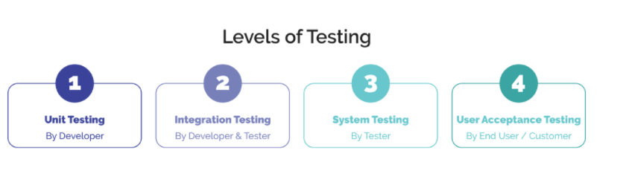

There are four levels of testing in SDLC

UNIT TESTING

Definition-Testing of internal logic of program called as unit testing. Unit testing done by developer

* Unit is nothing but single program or module
* Unit testing involves the testing of each unit or an individual component of the software application. It is the first level of functional testing. The aim behind unit testing is to validate unit components with its performance.
* A unit is a single testable part of a software system and tested during the development phase of the application software.

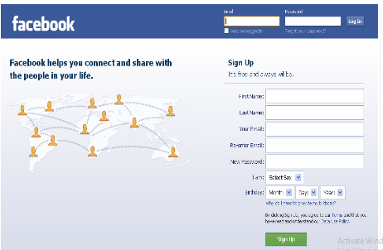

MODULE1(sign- up page )

INTEGRATION TESTING

Definition-Testing of communication between different modules called as integration testing

Integration testing is the second level of the software testing process comes after unit testing. In this testing, units or individual components of the software are tested in a group.

The focus of the integration testing level is to expose defects at the time of interaction between integrated components or units.

[Unit testing](https://www.javatpoint.com/unit-testing) uses modules for testing purpose, and these modules are combined and tested in integration testing. The Software is developed with a number of software modules that are coded by different coders or programmers. The goal of integration testing is to check the correctness of communication among all the modules.

Once all the components or modules are working independently, then we need to check the data flow between the dependent modules is known as **integration testing**.

Integration testing done by developer

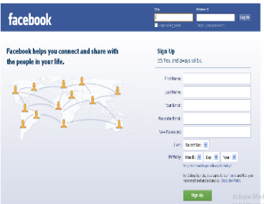 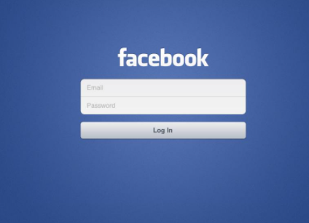 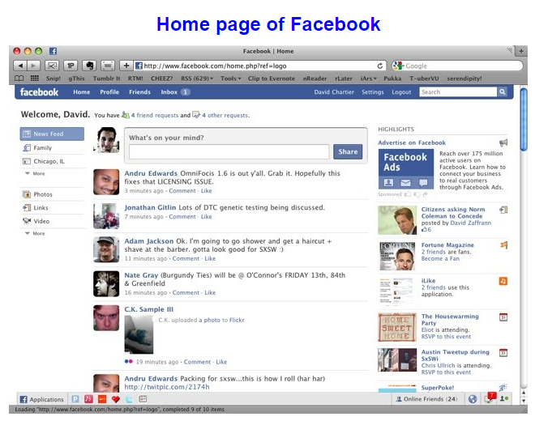

MODULE -1 (sign-up page ) MODULE- 2 (login page) MODULE-3(Home page)

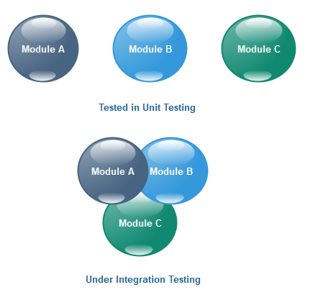

SYSTEM TESTING

Once build received from developer after completion of unit and integration testing tester start to do testing

System testing done by tester only

System testing includes

1.functional and

2.non functional testing

* **Functional testing** verifies each function/feature of the software whereas **Non Functional testing** verifies **non**-**functional** aspects like performance, usability, reliability, etc...
* Functional testing is based on customer's requirements whereas NonFunctional testing is based on customer's expectations.
* In system testing we don’t know internal logic but still we are testing software according to customer requirement so its called as black box testing

All test engineer comes under system testing

UAT(User Acceptance Testing )

**Once** testing team completed their testing they will handover software to customer

**Customer don’t use software directly in production (live ) ,before that they do certain kind of testing called as UAT (user acceptance testing )**

**They can identify defect in UAT**

**Once UAT is succesfully done the software moved to production environment (live invironment)**

UAT includes two kind of testing

* 1. Alpha Testing

Testing perform to find /identify bug before releasing product to user

* 1. Beta Testing

Testing perform by the client or are involve in this testing

* Error: A mistake in coding called as error
* Defect: error found by tester called defect
* Bug: defect accepted by development team called bug
* Failure: build does not meet the requirements then it is failure